**PROJECT REPORT**

**DocSpot: Seamless Appointment Booking for Health**

**Team Name - Team DocSpot**

|  |  |
| --- | --- |
| **Team Members:** | |
| **Gandepalli Radha Krishna** | 23MH1A05M2 (Team Leader) |
| **Monaj Kumar Ummadisetty** | 23MH1A05D6 |
| **Kumar Surya Kudipudi** | 23MH1A0530 |
| **Mukesh Guruvelli** | 23MH1A0522 |

INTRODUCTION:

## **Project Overview**

### DocSpot is a modern and user-friendly web application built using the MERN stack (MongoDB, Express.js, React.js, Node.js) that simplifies the process of booking doctor appointments. It is designed to help patients, doctors, and admins manage appointments effectively.

**Key Features Explained**

**1. Online Appointment Booking**

* Users (patients) can easily book doctor appointments through the platform from home.
* No need for phone calls or physical visits to clinics for scheduling.

**2. Doctor Browsing & Filtering**

* Users can **search** and **filter** doctors by:
  + **Specialization** (e.g., cardiologist, dermatologist)
  + **Location**
  + **Availability (date & time)**
* Makes it easy to find the right doctor quickly.

**3. Real-Time Slot Availability**

* The system shows **available time slots** for each doctor in real time.
* Users can select their preferred slot for appointments.
* Prevents double-booking and improves scheduling efficiency.

**4. Appointment History & Management**

* Users can **view their appointment history**, including:
  + Scheduled appointments
  + Past appointments
  + Cancelled appointments
* Users can **cancel** or **reschedule** appointments if needed.

**5. Notification System**

* Users and doctors receive **notifications**:
  + Appointment confirmations
  + Status updates (approved, scheduled, cancelled)
  + Reminders for upcoming appointments

**6. Doctor Dashboard**

* Approved doctors can log in and:
  + View all their appointments
  + Accept or reject appointment requests
  + Update appointment status (e.g., completed, cancelled)
  + Manage available timings and fees

**7. Admin Panel**

* Admin oversees the entire platform:
  + **Approves doctor accounts**
  + **Manages users**
  + **Monitors system activity**
  + Ensures platform policies and security are followed

**8. Secure Authentication**

* The app uses **JWT (JSON Web Token)** for secure login and session management.
* Passwords are stored securely using **bcrypt hashing**.

**Purpose of the Project:**

The main purpose of **DocSpot: Seamless Appointment Booking for Health** is to **simplify and digitize the process of booking doctor appointments** through an online platform. It is designed to benefit **patients**, **doctors**, and **administrators** by creating a centralized and efficient appointment management system.

**Key Objectives:**

**To Provide Easy Access to Healthcare Services**

* Allow users to book appointments without visiting the hospital or calling reception.
* Save time and effort for both patients and healthcare providers.

**To Reduce Manual Work and Errors**

* Eliminate traditional paper-based or phone-based booking.
* Prevent double-bookings and missed appointments through digital tracking.

**To Enable Real-Time Scheduling**

* Offer a system where users can see real-time doctor availability.
* Help doctors manage their slots efficiently.

**To Improve Communication Between Patients and Doctors**

* Send instant notifications and appointment updates.
* Allow document uploads for prior medical history.

**To Offer Role-Based Access**

* Different panels and responsibilities for **Users**, **Doctors**, and **Admins**.
* Ensure proper governance and security of data.

**To Support a Scalable and Modern Web Solution**

* Build the platform using the **MERN Stack (MongoDB, Express.js, React.js, Node.js)** for better performance and scalability.
* Suitable for clinics, hospitals, or telehealth services.

**IDEATION PHASE**

**PROBLEM STATEMENT:**

**In today's fast-paced world, booking a doctor's appointment is often a time-consuming and frustrating process. Patients are typically required to call clinics, wait in long queues, or physically visit hospitals just to schedule a consultation. This traditional method is inefficient and prone to issues such as:**

* **Overbooking and scheduling conflicts**
* **Lack of real-time availability**
* **Communication gaps between patients and doctors**
* **Difficulty in managing medical records and follow-ups**
* **No centralized platform for different roles (patients, doctors, admins)**

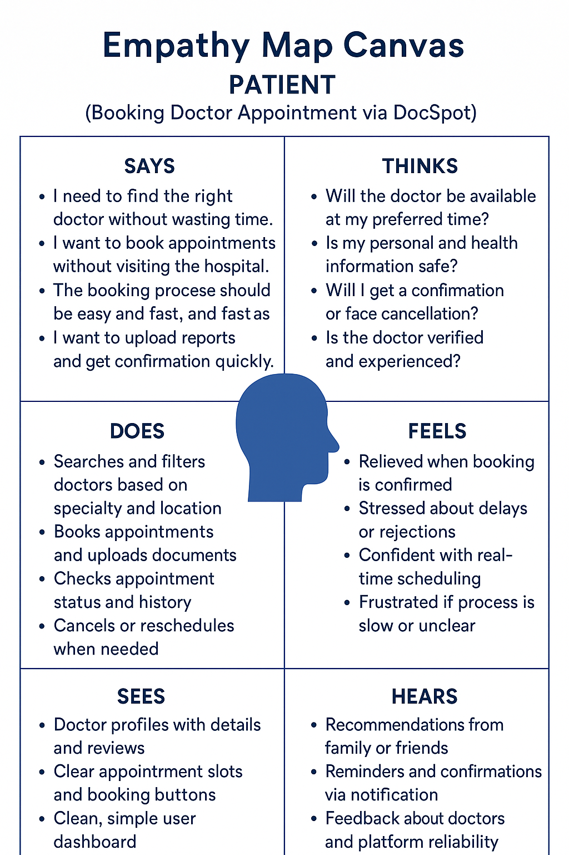



**Brainstorming**

**Problem Statement:**

In today's fast-paced digital world, patients face challenges in finding reliable, user-friendly platforms for booking doctor appointments. Many existing platforms are either cluttered, difficult to navigate, or lack proper doctor availability insights. Additionally, managing medical appointments across various specialties and clinics can be time-consuming and frustrating for users.

**Proposed Solution:**

**DocSpot** is a full-stack healthcare appointment booking platform built using the **MERN (MongoDB, Express.js, React.js, Node.js)** stack. It provides a seamless interface for users to find doctors, book appointments, and manage their healthcare schedules from one place. The system supports user authentication, doctor search by specialty/location, appointment scheduling, booking history, and an admin dashboard for managing doctors and bookings.

The application focuses on a clean, responsive UI with **role-based access** for users (patients), doctors, and admins. Doctors can manage their profiles, availability, and appointments, while patients can view doctor details, book slots, and track appointments. Integration with secure data handling and notification alerts enhances user experience and reliability.

**Target Users:**

* **Patients**: Looking for an easy and secure platform to book medical appointments online.
* **Doctors/Clinics**: Want to manage appointments, availability, and interact with patients without technical complexity.
* **Admin/Clinic Managers**: To handle doctor approvals, user management, and overall system monitoring.

**Expected Outcome:**

The final product will be a responsive and secure web application that simplifies the healthcare appointment process for both patients and doctors. **DocSpot** will provide an intuitive experience for booking and managing medical appointments, promote easy access to healthcare professionals, and support admin-level management of users, doctors, and schedules. The platform aims to become a trustworthy, all-in-one solution for digital healthcare appointment needs.

**Requirement Analysis:**

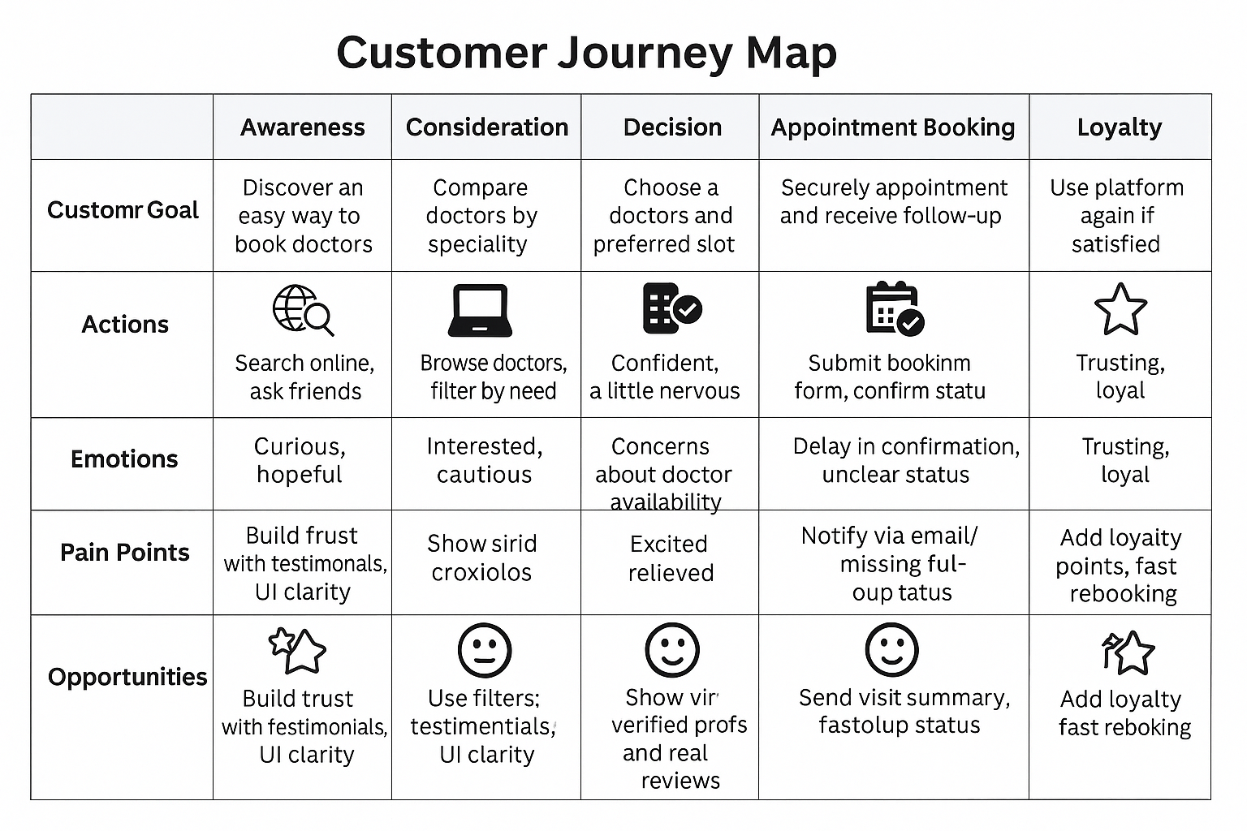

### **Solution Requirements for DocSpot**

### **🔹 Functional Requirements**

### **User Authentication:**

### **Use registration & login (for patients, doctors, admin).**

### **Role-based access control (RBAC).**

### **Doctor Management:**

### **Doctors can create & manage profiles.**

### **Set availability slots.**

### **View, accept, or cancel appointments.**

### **Patient Module:**

### **Search doctors by specialty, name, or location.**

### **View doctor profiles with details (specialization, availability, experience).**

### **Book/cancel appointments.**

### **View appointment history.**

### **Appointment Scheduling:**

### **Real-time slot availability.**

### **Booking confirmation via notification or email.**

### **Avoid double-booking through slot validation.**

### **Admin Dashboard:**

### **Manage all users (doctors, patients).**

### **Approve/reject doctor registrations.**

### **View appointment statistics and logs.**

### **Respond to user queries or issues.**

### **Notifications:**

### **Appointment confirmation, reminders, and cancellations (email/alerts).**

### **Search & Filter:**

### **Smart search bar with filters (e.g., by city, specialization, date).**

### **🔹 Non-Functional Requirements**

### **Responsiveness:**

### **Works seamlessly across devices (desktop, tablet, mobile).**

### **Security:**

### **Password encryption.**

### **Secure login using JWT.**

### **Role validation for protected routes.**

### **Scalability:**

### **Easily add more doctors, users, and appointments as needed.**

### **Performance:**

### **Fast API response using optimized queries and indexing.**

### **Maintainability:**

### **Modular backend structure with clean code separation.**

### **🔹 Technical Stack**

### **Frontend: React.js with Tailwind CSS or Bootstrap**

### **Backend: Node.js with Express.js**

### **Database: MongoDB (with Mongoose)**

### **Authentication: JWT & bcrypt**

### **Hosting: (Example) Vercel for frontend, Render/Heroku for backend**

### **Other Tools: Postman for API testing, GitHub for version contro**

**Data Flow Diagram:**

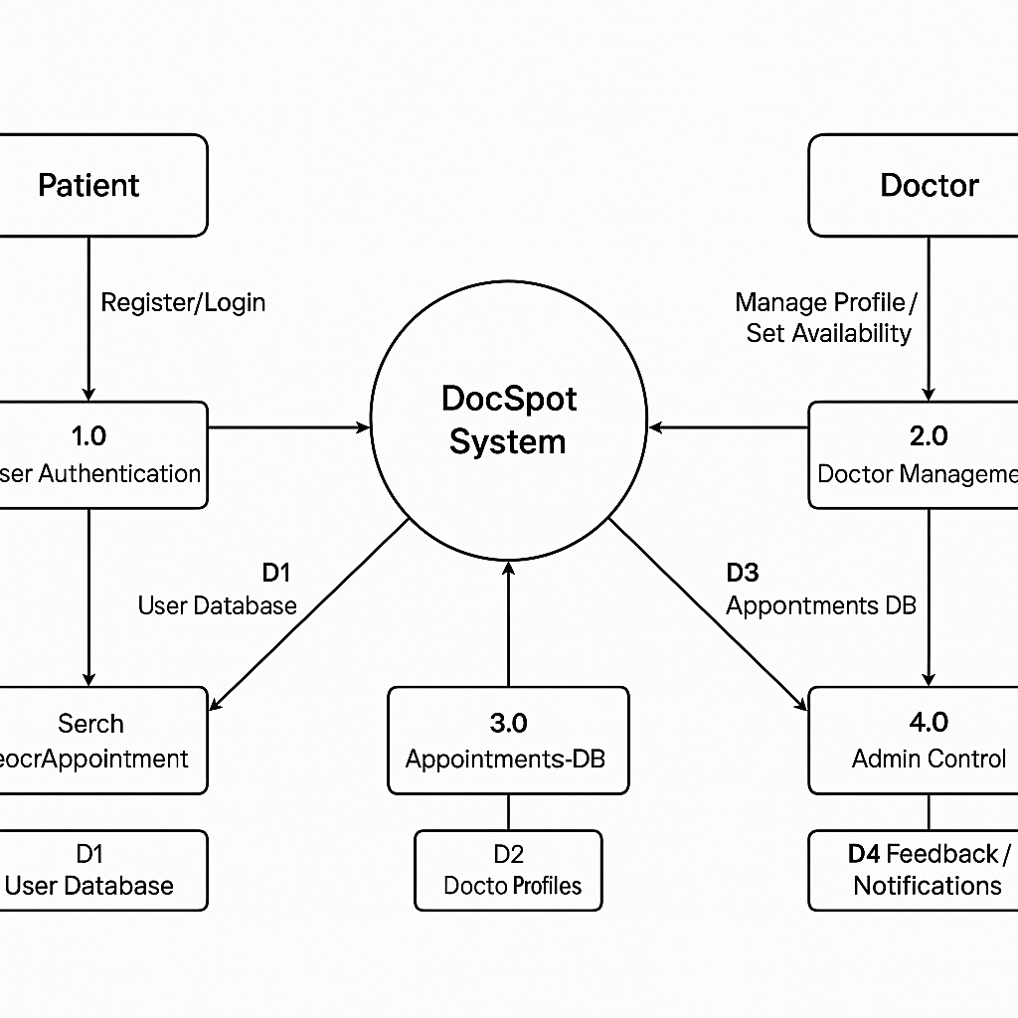

### **Technical Requirements:**

**Frontend:**

* **Languages & Frameworks**:
  + HTML5, CSS3, JavaScript
  + React.js (v18+)
* **Styling & Responsiveness:**
  + Tailwind CSS or Bootstrap
* **UI Enhancements**:
  + Toasts/Alerts for actions
  + Form validation and error handling

**Backend:**

* **Languages & Frameworks**:
  + Node.js (v16+)
  + Express.js (v4+)

**Database:**

* **NoSQL Database**: MongoDB
* **ODM**: Mongoose

**Development Tools:**

* **IDE**: Visual Studio Code (VS Code)
* **API Testing**: Postman
* **Version Control**: Git & GitHub

**Others:**

* **Authentication**: JWT-based secure login
* **File Storage**: Cloudinary or Firebase (for uploading reports/documents)
* **Payment Integration** *(Optional)*: Razorpay/Stripe (for doctor consultation fees)

**Functional Requirements – DocSpot**

**User Authentication:**

* Secure Signup/Login for users (patients) and doctors
* Role-based access (Admin, Doctor, Patient)

**Doctor Management (Admin & Doctors):**

* Admin dashboard to approve, block, or delete doctors
* Doctors can update profile, specialization, fees, and available slots

**Appointment Booking:**

* Search doctors by filters (location, specialization, availability)
* View doctor profiles with timing and consultation fee
* Book appointment with date/time & upload medical documents
* Real-time booking confirmation

**User Account Features:**

* View profile and update details
* Appointment history and status tracking
* Download prescriptions or follow-up notes

**Admin Features:**

* Manage users and doctors
* Approve new doctor registrations
* Monitor appointment activity and platform usage

**Frontend Features:**

* Fully responsive design for mobile, tablet, and desktop
* User-friendly dashboards for all roles
* Notifications for booking status (pending, approved, rejected)

**⚠️ Constraints & Challenges**

**Platform Scalability:**

* Handle increasing number of users and doctor listings
* Maintain fast response times during high traffic

**Data Security & Privacy:**

* Protect patient information, medical documents, and login credentials using JWT and encryption

**Real-Time Appointment Handling:**

* Avoid appointment conflicts
* Provide immediate feedback to user and doctor

**Database Optimization:**

* Efficient querying for search and filter operations
* Scalable schema design for patient, doctor, and appointment data

**User Experience (UX):**

* Intuitive, clean interface for all user types
* Smooth booking flow from search to confirmation

**🧩 Problem Statement – Rewritten for DocSpot**

As healthcare increasingly shifts toward digital platforms, **online doctor appointment booking** emerges as a critical service model. However, traditional booking systems are often inefficient, time-consuming, and lack transparency. Patients face delays, poor communication, and confusion about doctor availability, while doctors and admins struggle with managing appointments and patient records.

This project aims to develop **DocSpot**, a secure, scalable, and user-friendly MERN stack-based platform that addresses these issues by:

* Enabling real-time, digital appointment booking
* Offering role-based dashboards for patients, doctors, and admins
* Improving healthcare accessibility and operational efficiency through smart technology.

**DocSpot – Appointment Booking Platform.**

**Front-end**

1. **HTML/CSS**  
   Use semantic HTML5 and CSS3 to build a clean, responsive, and accessible user interface for patients, doctors, and admins.
2. **JavaScript**  
   Enhance user experience with interactivity (form validation, dynamic UI updates, filtering).
3. **Front-end Framework**  
   Use **React.js** to create reusable UI components, manage application state (using Redux/Context API), and build a single-page application (SPA).
4. **Responsive Design**  
   Ensure cross-device compatibility (desktop, tablet, mobile) using frameworks like Bootstrap, Tailwind CSS, or Material UI.

**Back-end**

1. **Programming Language**  
   Use **Node.js** with JavaScript for writing scalable backend logic.
2. **Framework**  
   Use **Express.js**, a lightweight Node.js framework, to define routes, handle APIs, middleware, and error handling.
3. **Database**  
   Use **MongoDB**, a NoSQL database, to store user profiles, appointment details, and doctor information.
4. **API Development**  
   Design a **RESTful API** to handle communication between frontend and backend (CRUD operations for users, doctors, and appointments).

**Database**

1. **Database Schema**  
   Create structured collections for Users, Doctors, and Appointments with defined fields like name, email, specialization, date, and status.
2. **Data Modeling**  
   Use **Mongoose** ODM to define relationships between documents (e.g., link appointments to users and doctors).
3. **Indexing**  
   Implement database indexing to speed up search queries (e.g., filter doctors by specialization or location).

**Security**

1. **Authentication**  
   Use **JWT (JSON Web Tokens)** for secure login and session management.
2. **Authorization**  
   Role-based access control (patient, doctor, admin) to restrict sensitive features.
3. **Data Encryption**  
   Encrypt sensitive user data like passwords using **bcrypt.js**; use HTTPS for secure communication.
4. **Security Updates**  
   Regularly update packages and use vulnerability scanners (like npm audit) to patch known security flaws.

**Server and Infrastructure**

1. **Cloud Hosting**  
   Host the app using cloud providers like **Render, Vercel, or Heroku** (or AWS for advanced scaling).
2. **Server Configuration**  
   Use .env configuration for secure environment variable management and setup CORS, request limits, and HTTPS headers.
3. **Load Balancing (Optional)**  
   Scale the backend with load balancing tools if serving high user volume.
4. **Monitoring and Logging**  
   Use tools like **LogRocket**, **Postman Monitor**, or **PM2 logs** to monitor errors and performance.

**Testing and Quality Assurance**

1. **Unit Testing**  
   Use tools like **Jest** or **Mocha** to test backend API functions and frontend logic.
2. **Integration Testing**  
   Validate that API routes (e.g., booking, authentication) interact correctly with the database.
3. **End-to-End Testing**  
   Use **Cypress** or **Playwright** to test full user flows like login → book → confirm → manage appointment.
4. **Performance Testing**  
   Use **Lighthouse** and **Postman** to benchmark load times and API response speed under different traffic levels.

**Project Design**

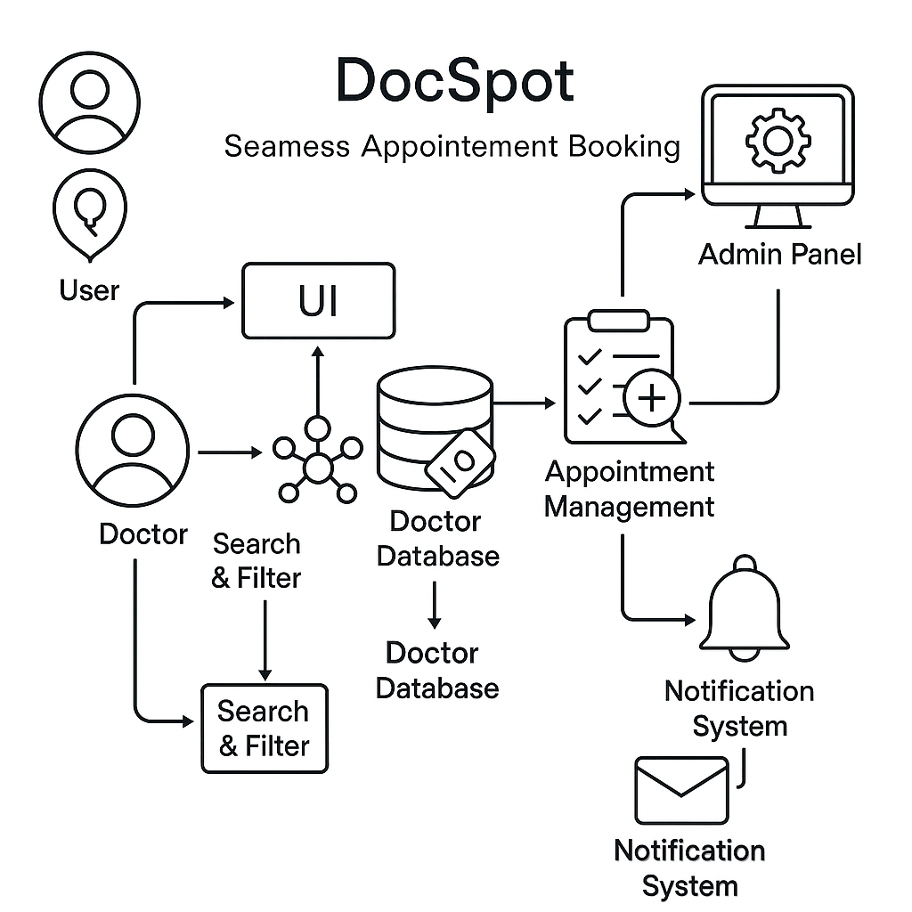

**System Flow:**

* **User Input** ➜ **Backend Validation** ➜ **MongoDB Data Storage**
* **Dynamic Doctor Listings** ➜ **User Interaction (React Frontend)** ➜ **Appointment Booking System**
* **Admin Dashboard** ➜ **Doctor Management** ➜ **Appointment & User Tracking**
* **Integrated Search & Filters** ➜ **Smart Navigation for Users**
* Uses **doctor_data.json / MongoDB** for real-time doctor availability and profile rendering
* Built using **MERN Stack** (MongoDB, Express.js, React.js, Node.js)

**User Flow (Patient):**

1. User lands on the **DocSpot homepage**
2. Uses **search bar** or **filter options** (specialization, location, availability) to find a doctor
3. Views **doctor profile** (timings, fees, experience, reviews)
4. Selects a time slot and uploads documents if required
5. Proceeds to **book appointment**
6. Gets confirmation and updates via dashboard notifications

**User Flow (Doctor):**

1. Registers and waits for **admin approval**
2. Once approved, logs in to access the **Doctor Dashboard**
3. Views and manages appointments
4. Accepts/rejects requests and adds visit notes

**User Flow (Admin):**

1. Logs in to the **Admin Panel**
2. Reviews and approves new doctor registrations
3. Manages users and tracks appointment activity
4. Handles platform settings and system monitoring

**UI/UX Considerations:**

* Fully **responsive design** for all devices (desktop, tablet, mobile)
* Clean **navigation bar** with options: Home | Doctors | Bookings | Profile | Logout
* Clear booking form and status tracking
* **Doctor cards** with profile picture, name, specialization, rating, and timing
* Real-time UI updates using **React states and REST APIs**
* **Admin dashboard** with intuitive controls for doctor approvals and user management

**Project Planning**

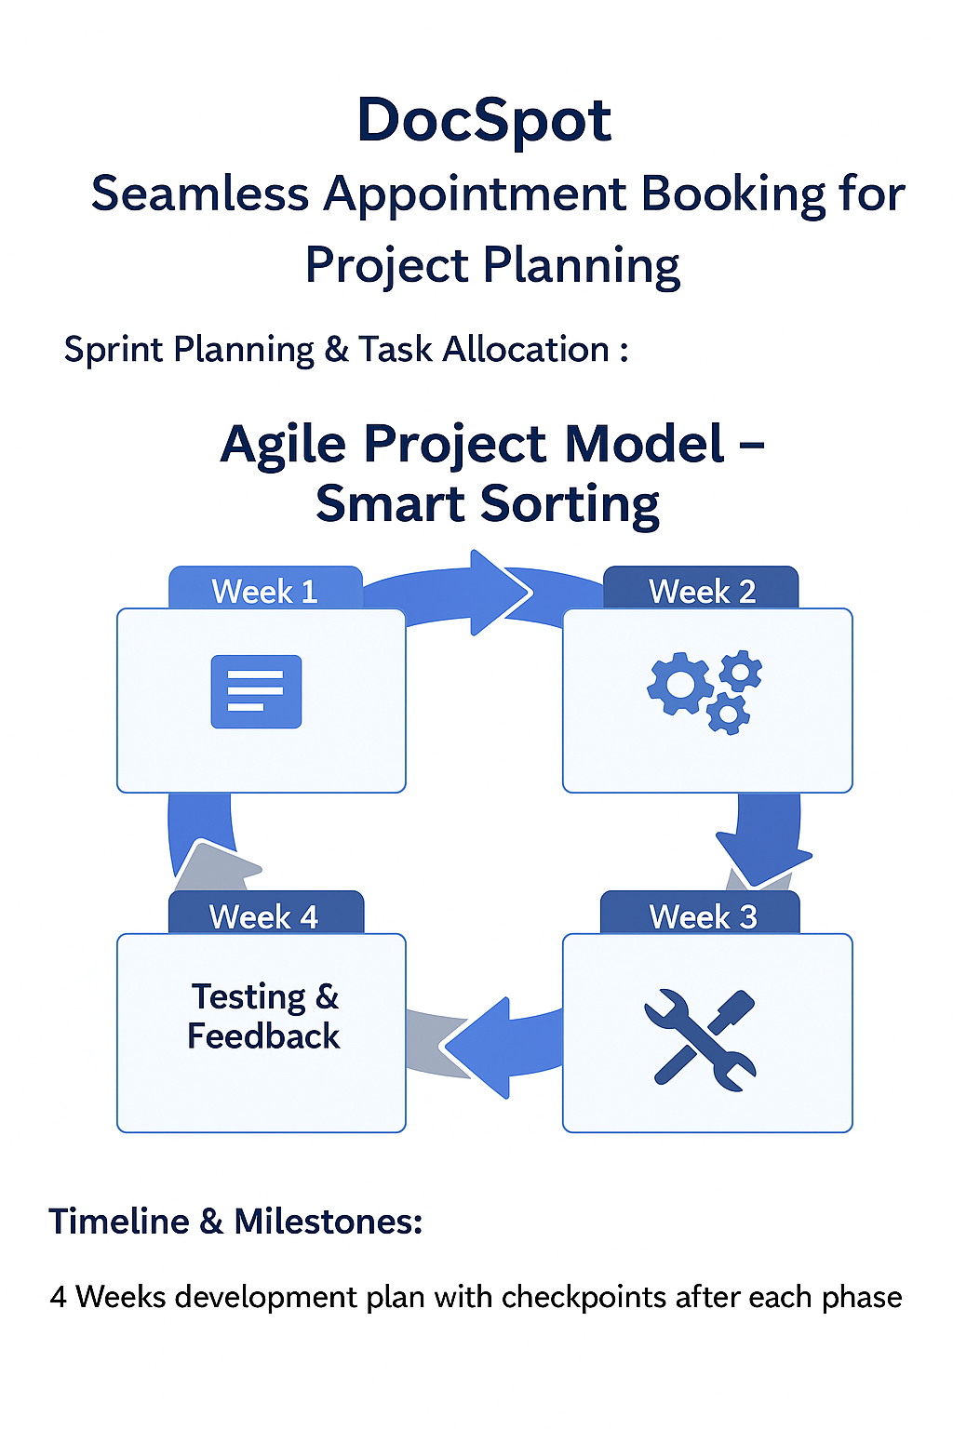

**Project Development**

**Technology Stack Used:**

* **MongoDB – NoSQL database used to store doctor, user, and appointment information.**
* **Express.js – Backend web application framework running on Node.js to create RESTful APIs.**
* **React.js – Frontend library used to build an interactive and dynamic user interface.**
* **Node.js – JavaScript runtime used to build backend logic and server functionality.**
* **HTML/CSS – Used with React for UI layout, styling, and responsiveness.**
* **Mongoose – ODM (Object Data Modeling) tool used to define schemas and interact with MongoDB.**
* **JWT & bcrypt.js – Used for secure user authentication and password encryption.**

**Development Process:**

1. **Requirement Analysis**
   * **Identified essential features like:**
     + **Doctor listings**
     + **Appointment booking system**
     + **User and doctor login**
     + **Admin dashboard**
     + **Notification system**
2. **Database Design**
   * **Created Mongoose schemas for:**
     + **Users**
     + **Doctors**
     + **Appointments**
   * **Defined relationships using references and indexes.**
3. **Frontend Development**
   * **Built reusable components in React:**
     + **Navbar, DoctorCard, BookingForm, NotificationBar**
   * **Applied Material UI, Ant Design, and responsive CSS for consistent layout.**
4. **Backend API Development**
   * **Developed RESTful APIs in Express.js to handle:**
     + **Authentication**
     + **Appointment creation and status updates**
     + **Doctor management**
     + **Admin approval system**
5. **Authentication & Authorization**
   * **Implemented JWT-based login and route protection for:**
     + **Doctors**
     + **Admin**
     + **Regular users (patients)**
6. **Admin Dashboard**
   * **Built a secured panel where admins can:**
     + **Approve or reject doctor applications**
     + **Manage users and appointments**
     + **Monitor system activity**

**Functional & Performance Testing**

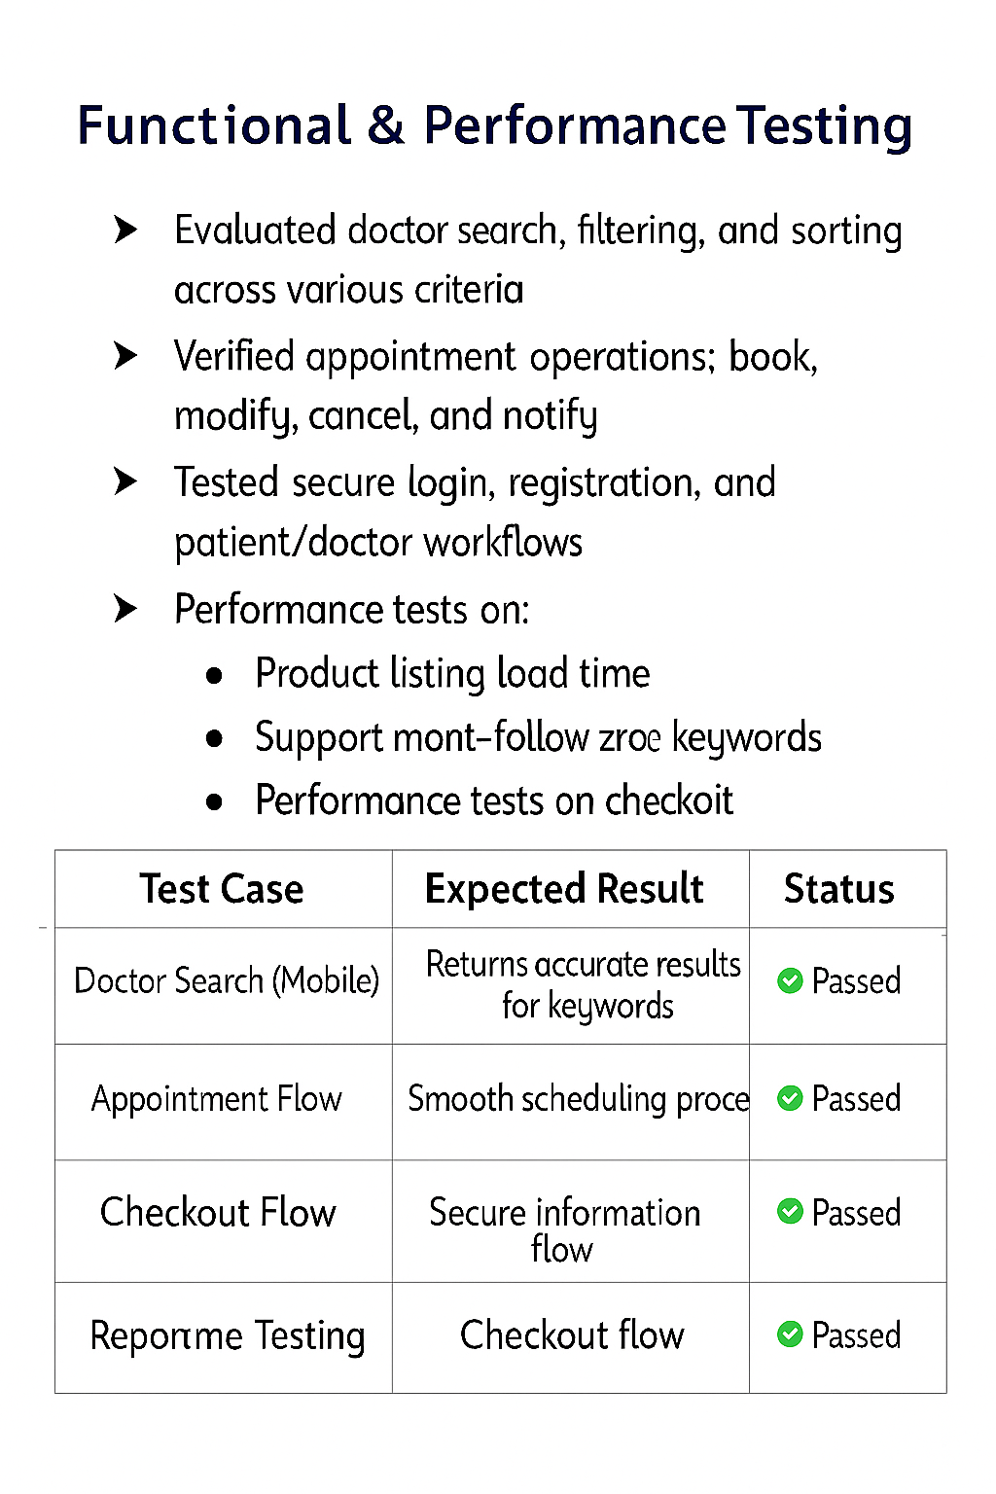

**Functional & Performance Testing – DocSpot**

**🔍 Test Cases Executed:**

🩺 **Doctor Search, Filtering, and Sorting**:  
Tested functionality to search doctors by specialization, location, availability, and rating.

📅 **Appointment Operations**:  
Verified booking, modification, cancellation, and notification features.

🔐 **Authentication Flows**:  
Tested secure login, registration, and protected access for doctors, patients, and admins.

📱 **Responsive Design**:  
Checked full mobile and desktop responsiveness for all key pages (Home, Booking, Profile, Dashboard).

⚙️ **Performance Testing Included**:

* Doctor listing load speed
* Appointment booking and update response time
* Search/filter query efficiency under load

**🎯 Benefits:**

1. **Convenience**: Enables users to find and book doctors from anywhere, anytime.
2. **Time-Saving**: Eliminates the need for physical visits or calls to clinics for appointments.
3. **Trust & Transparency**: Verified doctor profiles and secure booking system build patient trust.
4. **Wide Access to Healthcare**: Offers access to doctors across multiple specialties and locations.

**👥 Target Audience:**

**Demographics:**

* Students, professionals, senior citizens
* Individuals across urban and semi-urban regions
* Patients looking for in-person or teleconsultation options

**Psychographics:**

* People who value digital health access, time-efficiency, and verified professionals
* Tech-savvy users looking for simple, fast, and secure booking systems

**📣 Marketing Strategies:**

1. **Social Media Campaigns**: Promote health tips, booking features, and doctor spotlights via platforms like Instagram, Facebook, and Twitter.
2. **Influencer Collaborations**: Partner with health bloggers and medical professionals to demonstrate usage and build trust.
3. **Email Reminders & Newsletters**: Send appointment reminders, health awareness content, and updates to registered users.
4. **Search Engine Optimization (SEO)**: Optimize keywords like *book doctor online*, *nearby appointment*, *DocSpot platform* for Google ranking.

## **Future Scope – DocSpot**

## **AI-Based Doctor Recommendations** Use machine learning algorithms to suggest doctors based on a user’s previous bookings, location, specialization preferences, and health history. ➤ *Enhances personalization and patient satisfaction.*

## **Voice Search Integration** Enable voice commands for doctor search, booking, and navigation through the platform. ➤ *Improves accessibility for mobile users and differently-abled patients.*

## **Automated Slot & Availability Management** Doctors can automate schedule availability, get booking alerts, and manage reschedules with minimal effort. ➤ *Reduces manual overhead for healthcare providers.*

## **Dedicated Mobile App (Android & iOS)** Launch a cross-platform mobile app for smoother booking experience and real-time notifications. ➤ *Improves convenience and engagement.*

## **Advanced Security Features** Implement **two-factor authentication**, **role-based access**, and **real-time threat detection** to secure user data and appointment records. ➤ *Builds trust and meets compliance (e.g., HIPAA, GDPR).*

## **Multi-Language & Multi-City Support** Add local language options and support booking in multiple cities/regions. ➤ *Expands reach across India and globally.*

## **Doctor Reviews & Ratings System** Let patients rate doctors, write reviews, and flag inappropriate behavior or service. ➤ *Encourages transparency and builds platform credibility.*

## **Loyalty Rewards & Referral Program** Introduce points for regular users, referrals, and feedback. Redeemable for discounts or free consultations. ➤ *Increases user retention and platform promotion.*

## **Admin Analytics Dashboard** Real-time dashboard for platform administrators to view metrics like:

## Active users

## Booked appointments

## Doctor approval rates

## City-wise performance ➤ *Helps in decision-making and platform optimization.*

## **Live Appointment Tracking & Teleconsultation Integration** Show real-time status of upcoming appointments.

## Include video/voice consultation options for virtual visits

## Notify patients when doctor is available ➤ *Modernizes healthcare delivery.*

## **Conclusion**

## **DocSpot** is built with the goal of simplifying healthcare access using the MERN stack and modern UI/UX principles. It bridges the gap between patients and doctors through secure, efficient, and user-friendly appointment booking.

## The platform's modular architecture and scalable design make it ready for future enhancements like AI-driven doctor suggestions, telemedicine integration, and global accessibility. As the healthcare industry continues to embrace digital transformation, **DocSpot is well-positioned to evolve into a comprehensive digital health ecosystem.**